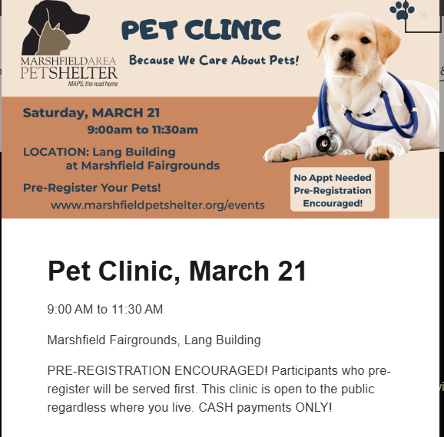

For more information please visit:
Pet Clinic — Marshfield Area Pet Shelter

